VIKKI WALLER FRSASA, BAVA, Cert. Min. B. Min.

Born Kent U.K. Sept 1940 Arrived Australia Sept 1965

STUDIES 1992-95 Bachelor of Ministry Adelaide College of Divinity.
1992 Lay Ministry Certificate Parkin Wesely College.
1990 Tapestry Summer School North Adelaide School of Art.
1987-90 Bachelor of Arts, Visual Arts University of S.A.
1978-80 Art &Craft Certificate. Aldgate S.A. TAFE
1957 Bromley School of Art

OFFICES HELD 2017- 2018 Chairperson Port Community Arts Centre
2017- 2020 Treasurer Royal South Australian Society of Arts
2015 - Trustee M & M Carbins Trust
2010 -2017 President Royal South Australian Society of Arts
2010-2017 Committee Member Port Community Arts Centre
2012 - Trustee Embroiderers’ Guild SA Inc
2010 -2012 Treasurer Embroiderer’s Guild SA Inc.
2006-2008 Director – RSASA
2003-2006 Vice- President- RSASA.
1987-1992 Secretary and Treasurer of RSASA
1990 voted Fellow of RSASA
1980 voted Associate member of RSASA
1975 - present Member Royal South Australian Society of Arts
Past member and treasurer of Adelaide Art Society – North Adelaide

EXHIBITIONS SOLO 2021 RSASA 50 year retrospective
2020 Pilgrim Uniting Church Advent/Cbhristmas
2019 Hughes Gallery Fullarton
2017-18 Enfield Uniting Church
2014 - Pilgrim Uniting Church hall Adelaide
2010 Prospect Gallery Nailsworth
2010 Pilgrim Uniting Church hall Adelaide
2008 Pilgrim Uniting Church hall Adelaide
2008 Uniting Church SA Synod gallery Adelaide
1994 “People of the Passion” St. Peter’s Cathedral.
1994 Uniting Church Blackwood SA
1993 St. Peter’s Cathedral Adelaide SA
1993 Langmeil Lutheran Church Tanunda SA
    - Plympton SA
1986 Strathalbyn SA
- Coober Pedy SA

1974 Clare SA `

EXHIBITIONS GROUP
2020 RSASA members group exhibitions
2020 Wild Fibres Group Gallery M
2019 RSASA members group exhibitions
2019 Wild fibres Group Hughes Gallery Fullarton
2019 Hospitality Group Buckingham Arms Fringe exhibition
2018 PCAC members exhibitions
2019 Wild Fibres Group. The Artisan Cafe Blackwood
2018 RSASA members group exhibitions
2018 Wild fibres Group Gallery M Marion
2018 Hospitality Exhibition Fringe at Buckingham Arms Hotel
2017 Wild Fibres Group Pepper Street Gallery
2017 Group exhibitions RSASA, PCAC, Embroiderers Guild SA
2016 Group Exhibitions RSASA, PCAC, EGSA, Rising Sun Hotel Kensington
2015 RSASA, PCAC, Cats in the Loft, St Vincent St. Port Adelaide
2014 Characters of the Fleurieu Mclaren Vale SA
2014 RSASA – group exhibitions
2010 SALA at RSASA 3 works
SALA at Embroiderer’s Guild S.A. 5 works
“From the studio” RSASA
2008 “Transformation” Group exhibition Blackwood Uniting Church – 3 works
2008 Adelaide College of Divinity - Fringe Exhibition – 3 works
2004 –2008 RSASA Exhibitions 1 or 2 works in each exhibition.
2004 “Encountering Australian Spirituality “ Adelaide College of Divinity 3 works
2003 10x10 Exhibition RSASA “Passing Parade” 3 works – quilts on stretchers
2003 Spring Exhibition RSASA “Canola” “Water Irises” “Lake Eyre” 3 Quilts
2002 Black & White RSASA “More than whites or blacks” Quilt
2002 Spring Exhibition RSASA – “Sprung” Quilt (cats)
2001 “Easter – Reflections through the arts”. Seaford Ecumenical Mission
2001 “The Art of Faith”. Uniting Church Synod. Adelaide.
2001 “Encountering Australian Spirituality” Adelaide College of Divinity 2 works
2000 Exploring Australian Spirituality 2 Adelaide College of Divinity 2 works
2000 Winter Exhibition RSASA
1999 UCA. Port Adelaide Church 150 years exhibition and celebration
1998 Exploring Australian Spirituality Adelaide College of Divinity
1997 Fellows Exhibition. RSASA
1996 Exhibition at Prince Alfred College.
1995 Autumn and Winter exhibitions. RSASA
1994 “Women Remembering the Future” Annesley College Adelaide
“Women Remembering the Future”. St. Peter’s Cathedral Adelaide
1994 “A World of Difference” John Dunn Fine Arts Gallery Bridgewater
1994 “Christmas Bowl” exhibition St. Peter’s Cathedral Adelaide
1994 “For the Family” Bethlehem House Adelaide.
“For the Family”. St. Peter’s Cathedral. Adelaide
1993 “Festival Exhibition” Langmeil Lutheran Church Tanunda
“Joy of Living Two ” Anticancer Foundation University of Adelaide
1992 “A Brush with the Stage” Festival Exhibition RSASA
1991 “Eyre Fair” Port Lincoln SA
“Walk a Barefoot Road”. Greenhill Gallery SA and national tour.
“AGM” SA Council of Churches. Seymour College Adelaide
“Enter at your own risk”. Loft Ga llery Adelaide
“Personal Visions.” RSASA Adelaide
1987 “Adelaide Sister City” Christchurch New Zealand
“A Twist in the Tightrope”. Underdale .SA
“Redefine Print”. Union Gallery Adelaide
1987 “Joy of Living”, Anti Cancer Foundation at Gallery on the Terrace, Adelaide
1987 Carclew Adelaide
Participated in many group exhibitions with the Adelaide Art Society,
Advertiser Open Air Art Exhibition & Royal SA Society of Arts since 1980

“Artist in Residence” and Seminars and Commissions

2008 “Towards Harmony” quilt on loan in Chapel of Reconciliation ACD - since sold
2004 “The Olgas” quilt on permanent loan in Chapel of Reconciliation ACD
2003 Commission Quilted banner Pacific Earth Charter Assembly, Brisbane Qsld.
2003 Commission Official banner for UCA Adelaide North West Presbytery.
2002 Meeting space decoration “The Hem of God’s Garment”
UCA National Assembly. Prince Alfred College Adelaide
2002 Workshop and quilted banner UCA Fellowships retreat Nunyara S.A.
2000 Quilted banner “Port Adelaide Church, 150 years” for UCA Port Adelaide
2000 Commission Quilted banner “Here we are + send us” for UCA National
Assembly. Prince Alfred College. Adelaide
1999 Commission Quilted banner “The Great Southland” with Nola Pearce
for Parkin Wesley College
Commission Quilted banner “Op Shop Open” for UCA Woodville Gardens
1997 three commissioned banners
1996 “Praise the Lord.” Wall hangings for UCA Port Adelaide.
1994 Curator and hanging of “Women Remembering the Future” Exhibition
1994 People of the Passion 7 paintings during evening worship service.
1992 Economics and Ethics Ecumenical workshop Church of Christ N. Adelaide
(five panels purchased by Catholic Church Adelaide)

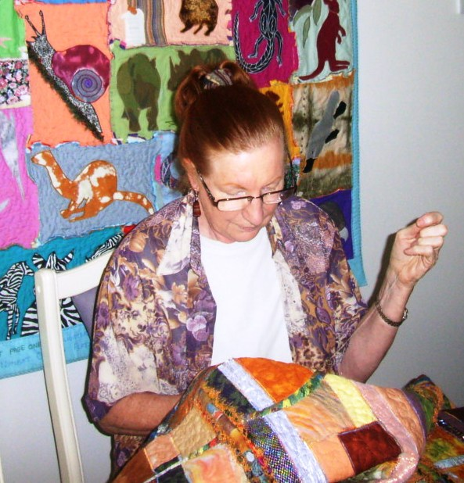
Throughout the past 30 years she has conducted workshops and acted as facilitator with church, community groups and with individuals to produce art works based on a particular Christian theme. These include 'The Great Southland' at Parkin Wesley College, 'Kata Tjuta Rainbow' at Adelaide College of Divinity and the 'Pacific Earth Charter 2003' which now hangs in Brisbane Town Hall. Some of her recent textile works can be seen in Pilgrim Church Hall, 12 Flinders St. Adelaide and in Enfield Uniting Church, Main North Road.
As a practising artist for over 50 years she has exhibited in many mediums, currently her passion is for multi-media works using fabric with a variety of dye processes, digital photography, paint and found objects.

She cares for her native plant garden, attends a local EFM gym 4 times a week and is a slave to two cats, Jackson and Ella.

